**LESSON 8 : ADVANCED WEB DEV - INTRODUCTION TO JS ES6**

**Teacher Prep:**

* Go through the Document thoroughly and create the projects as guided.
* Download Node from [here](https://nodejs.org/en/download/)depending on your system

**Project Showcase: (to be done at the start of the class at teacher end)**

* Open the provided project on VS Code before the class starts and check the live view on your browser.

**What is JS ES6?**

* JavaScript ES6 (also known as ECMAScript 2015 or ECMAScript 6) is the newer version of JavaScript that was introduced in 2015.
* This allows us to write less code and do more.
* This makes it more readable and easy to use.

**Basic steps included:**

* Add Node.js in your VSCode.
* Explanation of concepts
* Create an HTML and CSS page.
* Create script.js file

1. Add Node.js in VS Code.

* Download Node from <https://nodejs.org/en/download/>
* Install in your system.
* Open Control Panel-> System and Security->System->Advanced system settings -> Environment variable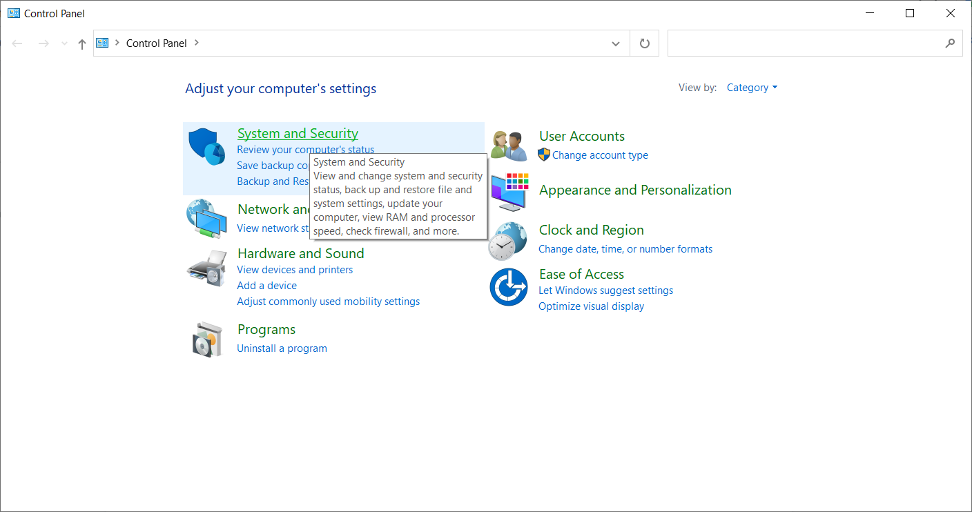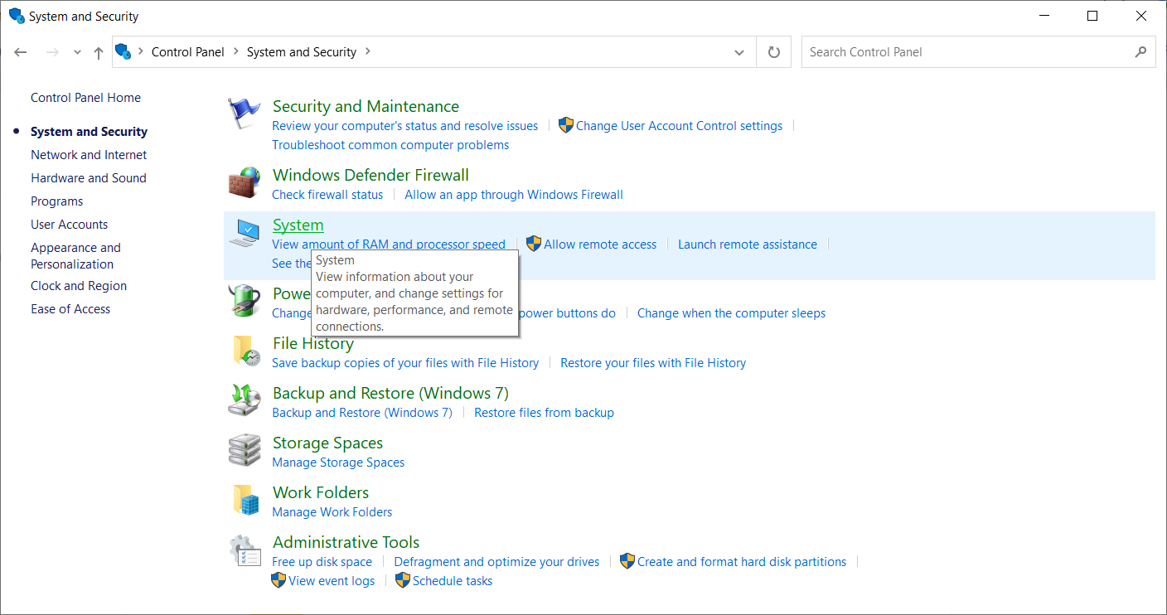

Settings Tab would open -> Navigate to Right side to find **ADVANCED SYSTEM SETTINGS.**

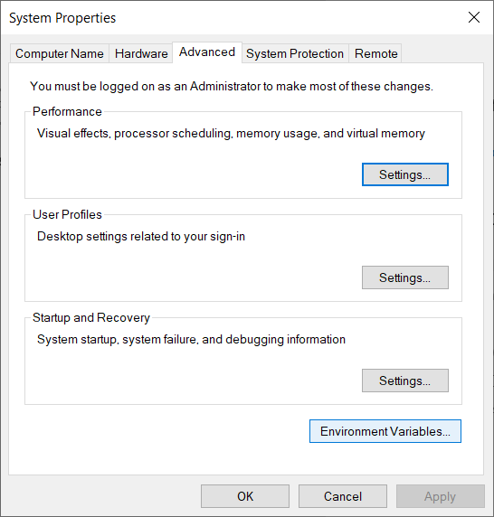

* In User variables or System variables, find variable PATH and add node.js folder path as value.

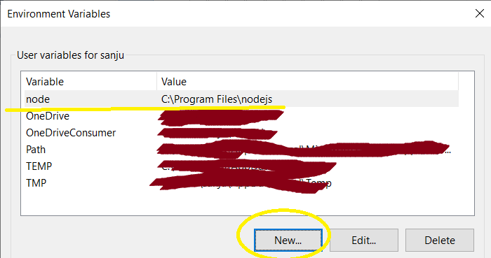

* Restart your IDE or computer

1. Explaination of Concepts
2. Difference between let and const Variables.

| **let** | **const** |
| --- | --- |
| cannot be redeclared  Eg: let x= “Jetlearn”  Let x=23  //shows error | cannot be Redeclared.  Eg:  const num = 9; // correct  num = 9; // This will give an error  Num = num + 10; // error |
| Variables defined with let must be Declared before use. | Variables defined with const cannot be Reassigned. |
| Variables defined with let have Block Scope.  Eg:  let x = 10;  // Here x is 10  {  let x = 2;  // Here x is 2  }  // Here x is 10 | Variables defined with const have Block Scope. |

**You can let the kids try these to find out the difference.**

**Arrow Functions:**

Arrow functions allows a short syntax for writing function expressions.

You don't need the function keyword

Eg:

**Without JS ES6: Using JS ES6**

var x=function(x, y){ const x =(x, y)=>{return x*y;}

return x * y;

}

**JS Events:**The **ES6 Events** are the part of every HTML element that contains a set of events that can trigger the JavaScript code.

An Event is an action or occurrence recognized by the software. It can be triggered by the user or the system. Mostly Events are used on buttons, hyperlinks, hovers, page loading, etc.

Some events:

1. onclick
2. onmouseover
3. onmouseout
4. onmouseup and onmousedown
5. onmousewheel

[Reference link for more Events.](https://www.geeksforgeeks.org/es6-events/#:~:text=The%20ES6%20Events%20are%20the,hovers%2C%20page%20loading%2C%20etc.)

4. Create HTML and CSS Page

index.html

<html>

<head>

<link href="https://fonts.googleapis.com/css2?family=Silkscreen&display=swap" rel="stylesheet">

<link href="style.css" rel="stylesheet">

</head>

<body>

<h1>Here's a Suprise for you...!!! </h1>

<h3>Get Ready for a blast </h3>

<form>

Enter your Name: <br>

<input type="text" id="name" placeholder="Your Sweet name :)"> <br>

<button type="button" id="btn">Click </button>

<h1 id="display"></h1>

<div id="dis">

<p id="content"></p>

<img id="img" src="">

</div>

</form>

<script src="script.js"></script>

</body>

</html>

Style.css

body{

text-align:center;

font-family: 'Silkscreen', cursive;

color:#FFFF00;

background-image: url("./images/background.gif");

}

#btn{

border-radius: 20px;

background-color:#FFFF00;

color:#DD2C00;

height:50px;

width:80px;

border:1px grey solid;

font-size: 20px;

margin-top:20px;

}

#name{

height:30px;

width:300px;

border: 2px blue solid;

border-radius: 10px;

margin-top: 20px;

}

#dis{

color:black;

text-align:center;

margin-left:10%;

width:80%;

font-family:sans-serif;

}

#dis p{

margin-top:10px;

}

**Kids can try different style according to their wish.**

5. Create script.js file

let show = () => {

let name = document.getElementById("name").value;

document.getElementById("display").innerHTML="Wish you a very Happy New Year to "+name;

document.getElementById("img").src="./images/2023.gif";

document.getElementById("content").innerHTML="New year, new hopes and newer beginnings- all of us ardently wait for the clock to strike 12 and usher in the new year. It's such a celebratory, positive time which keeps everyone in good spirits!";

document.getElementById("dis").style.color="#FFFFFF";

}

document.getElementById("btn").addEventListener("click", show);

// //cd.. ==> to to go back [change directory]

To run only the JS file ->

Open terminal in VSCode

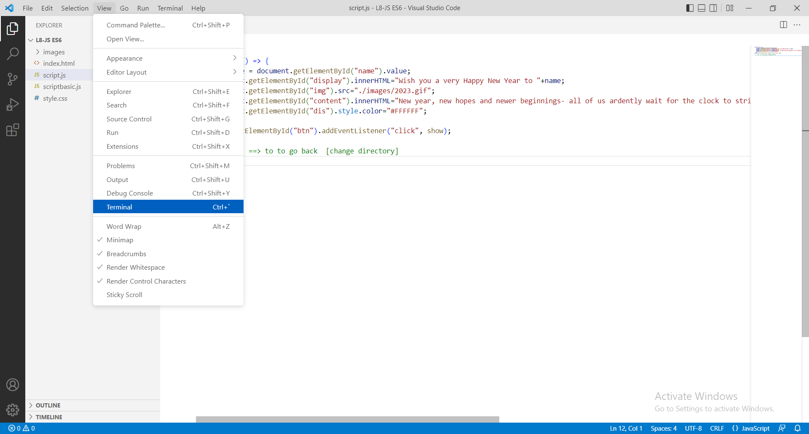

Type node filename.js

